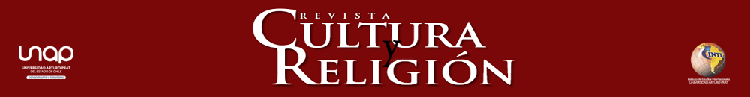
AGREEMENT WITH THE AUTHORS

To:
Editorial team
REVISTA CULTURA Y RELIGIÓN
UNIVERSIDAD ARTURO PRAT

I/we hereby state that the article “ARTICLE TITLE” that I/we wrote and submitted to Revista Cultura y Religión for evaluation and possible publication:
follows the editorial guidelines and rules;
is an original article that has not been submitted to or is under consideration for publication in other print or digital media (journals or books);
the author(s) has/have all of the rights and thus will be held responsible for any claim related to intellectual property rights;
the authors will cede the proprietary rights to the journal in perpetuity if the article is accepted for publication;
I/we state that each of us as co-authors have made an important and substantial contribution to the manuscript submitted to the journal;
I report the following conflicts of interest:

The author(s) must include the following information below their signature:
Full name (Pen Name) Institution on behalf of which the manuscript is submitted (Affiliation)
ORCID
Email address
Country (Affiliation)
Date (on which this letter is signed)
Statement of contribution to the article if two or more authors submit the text (maximum of 2 lines):

